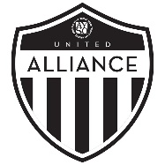
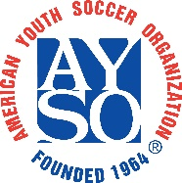
Alliance RC Confirmation Document

Admission to Alliance requires Regional Commissioner approval prior to submission to the Section program. Key points that all RC’s should understand are listed below:

- Alliance teams will need field space for practices and pitches for home games.
  - Leagues generally schedule all Alliance matches, and often don’t release the schedule until a few weeks before the scheduled start date
  - If home fields are shared between Core and Alliance, reserve kickoff times for consecutive Alliance home games, so that Core matches are not scheduled between Alliance games on the same day.
  - In cases of Regions with very few Alliance teams, home matches may be scheduled together on a shared field with neighboring Regions. Regions sharing fields should split the rental costs equally.
  - Club leagues often require good quality pitches. Inability to provide above average field space might result in exclusion from the program.
- This coach will adhere to the Six Philosophies of AYSO, notably “Everyone Plays,” and ensure all registered players will play a minimum of half of every match, even if other club teams do not.
- The RC affirms that this proposed team has registered players in an AYSO program, and the cumulative number of proposed Alliance players in proportion to Core players does not exceed 25%.
- The RC affirms that the team’s volunteers (Head Coach, Assistant Coach, Team Manager, Referees, etc.) are registered in AYSO, and have completed SafeSport, Live Scan, Safe Haven, CDC, and all certifications.
- The RC affirms the Head Coach and Assistant Coach have completed their respective 10U, 12U, Intermediate (U14), or Advanced (U16/19) Coach certifications, and have a history of excellent coaching achievement.
- The Head Coach and Assistant Coach must have, or obtain before the season starts, the appropriate US Soccer certification as required by the state association or league.
- The RC affirms that this proposed team will be competitive.
- The RC or registrar must create an “Alliance” registration on their Sports Connect page for players to enroll.

Area: ______________ | Region: ______________ |  | Boys / Girls: ______________
Birth Year: ______________
Team Name: _____________________________
Head Coach Name: ____________________ |  | Head Coach Email: ____________________
Asst. Coach Email: ____________________ |  | Asst. Coach Email: ____________________
RC Name: ____________________ |  | RC Email: ____________________
RC Signature: ____________________
AD Acknowledgement: ____________________ |  | SD Acknowledgement: ____________________

