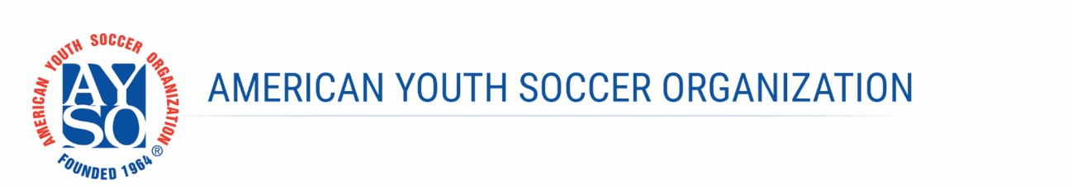

<Date>

Dear <name>:
This letter confirms that the Referee Abuse Prevention Program (RAPP) Disciplinary Panel (“the Panel”) for AYSO Area <Section/Area> met to review incidents that occurred on <date>. The Panel determined that you committed <Level 1 non-physical> referee abuse, <and that there were no penalty multipliers that applied>. Accordingly, the Panel has recommended that you be suspended for <number> games, in accordance with the penalties listed in the AYSO Referee Abuse Prevention (RAP) Policy (U.S. Soccer Policy 531-9, as adopted by the AYSO National Rules & Regulations). I, as the Area <Section/Area> Director, have accepted this recommendation, and you are hereby suspended, effective immediately. The suspension applies to activities and events as a volunteer, as a player, or as a spectator. Referee abuse of any kind is inconsistent with the AYSO philosophies and endangers AYSO programs by jeopardizing our ability to recruit and retain qualified referees to officiate games. And, as you know, without referees, there are no AYSO games.
You may request a review of this decision. In that case, either I or a disciplinary review panel will consider all of the information submitted, including any additional information you may wish to provide, and present me with a recommendation. Among other things, the result of such a review can have the following results: (i) not changing the original decision made by the RAPP Disciplinary Panel, (ii) terminating your suspension, (iii) modifying your suspension (either increasing or decreasing the sanction), or (iv) converting your suspension to a permanent ban from AYSO based upon its severity.
If you wish to have such a review, I must receive your written request within 14 days from the date at the top of this letter. You can submit such a request by email to me at <Area Director email address>. Your suspension will remain in place until the review is completed.
If you fail to request a review, the decision will become final. Your suspension will be enforced throughout AYSO and will be reported to the United States Soccer Federation so that it can be enforced throughout all U.S. Soccer’s member organizations.
If you request a review, your suspension will continue in full force and effect pending further written notice. If you believe grounds exist to remove your suspension sooner, you may send me written information and statements you think I should consider. However, you must request a review by the date fixed above unless you have received written notice from me that your status has been changed to your satisfaction.

Once your suspension is complete, AYSO welcomes you back to its events as a full participant. But please be aware that subsequent instances of referee abuse may result in increased sanctions, up to and including a lifetime ban from all AYSO activities. For more information about AYSO’s RAP Policy, I encourage you to review the materials available on AYSO’s Website https://wiki.ayso.org/wiki/Category:RAP, as well as those at https://ussoccer.com/rap.
Sincerely,

<Area Director Name>
Area <Section/Area> Director
cc:
<name>, Regional Commissioner, Region <No.>

Page 2 of 2

