
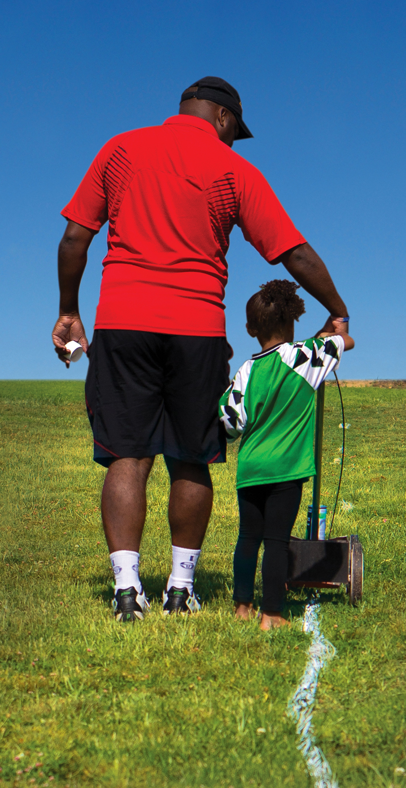
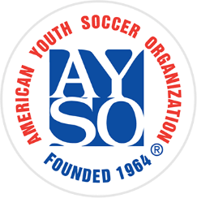

Coaches and Referees needed!

We’ll teach you everything you need to know!
Contact us today at:
555-123-4567 or inbox@email.com for more information.

Help make a positive impact in the lives of kids in your community by becoming an AYSO volunteer this season!
BECOME AN AYSO
VOLUNTEER TODAY!

Everyone Plays® | Balanced Teams
Open Registration | Positive Coaching Good Sportsmanship | Player Development
NO EXPERIENCE
NECESSARY!
BECOME AN
AYSO VOLUNTEER TODAY
BECOME AN
AYSO VOLUNTEER TODAY

