

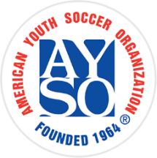
BECOME AN

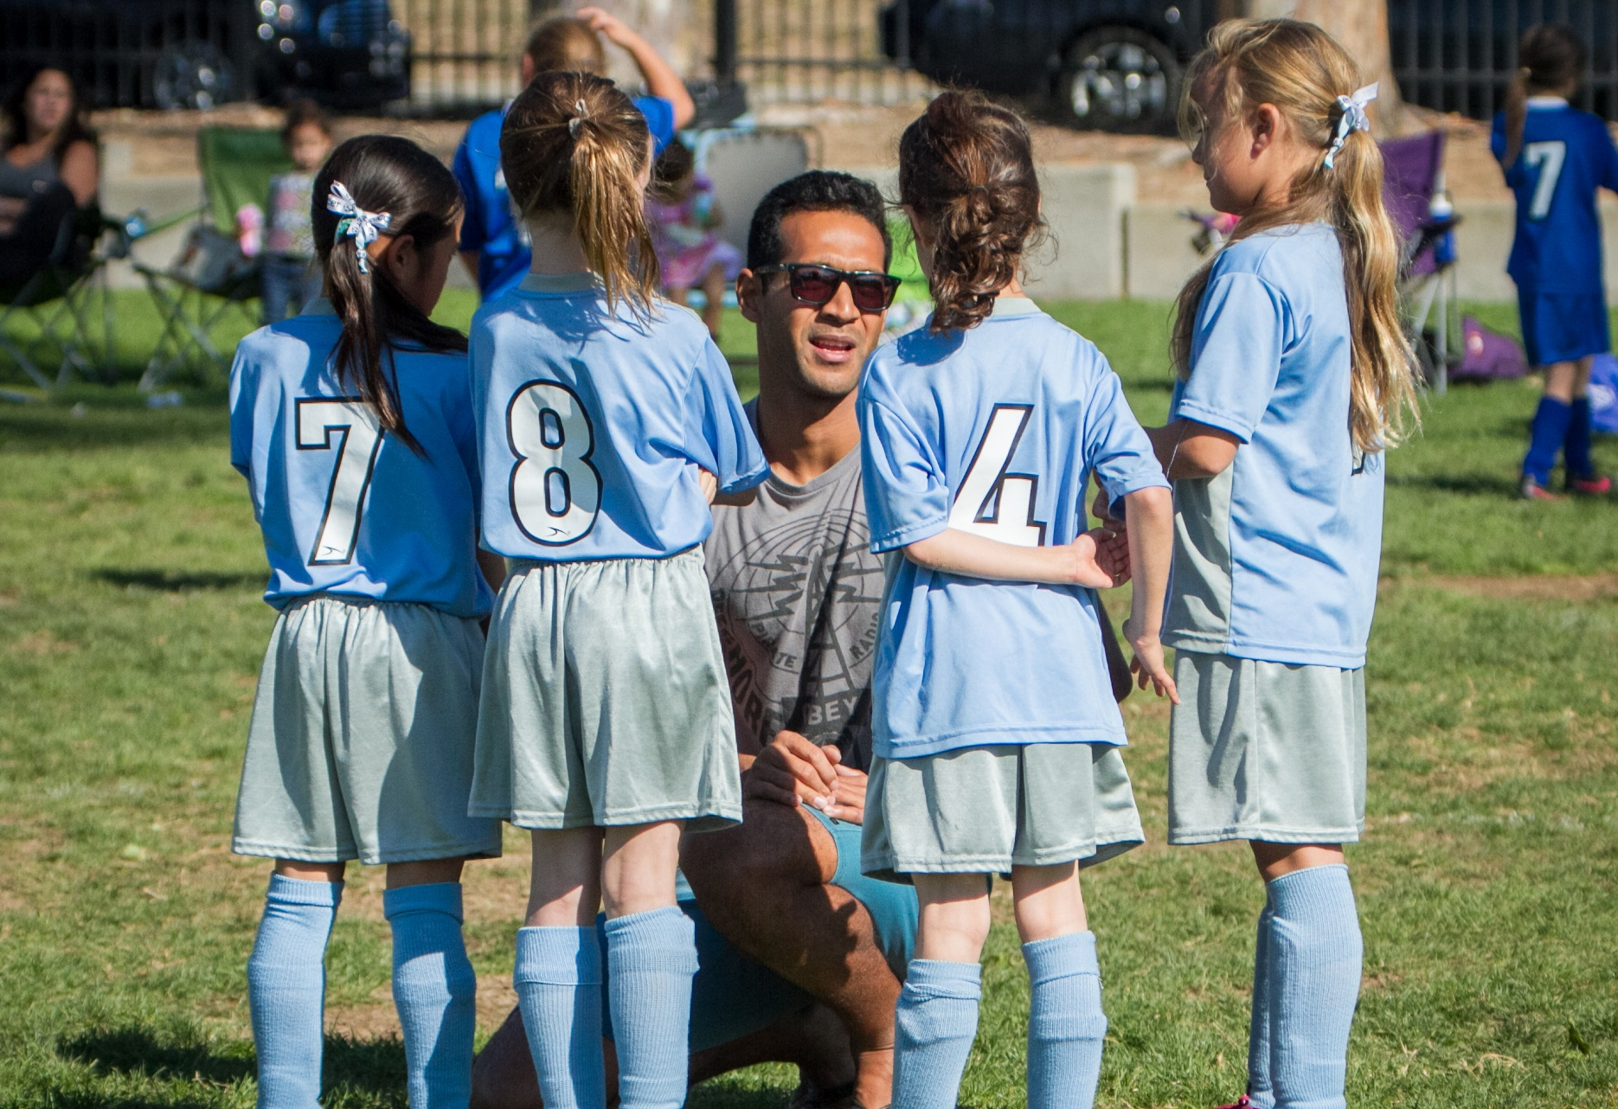
Contact us today at: 555-123-4567 or inbox@email.com for more information.
Coaches and Referees needed!

We’ll teach you everything you need to know!
Help make a positive impact in the lives of kids in your community by becoming an AYSO volunteer this season!

Everyone Plays® | Balanced Teams | Open Registration
Positive Coaching | Good Sportsmanship | Player Development
NO EXPERIENCE
NECESSARY
AYSO VOLUNTEER TODAY

