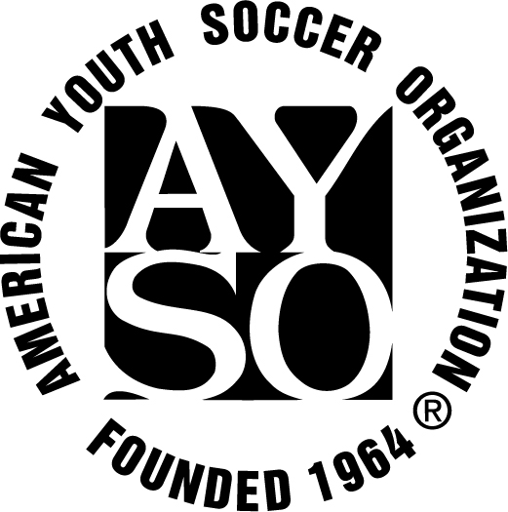

Standard Regional Policies & Protocols

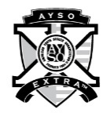
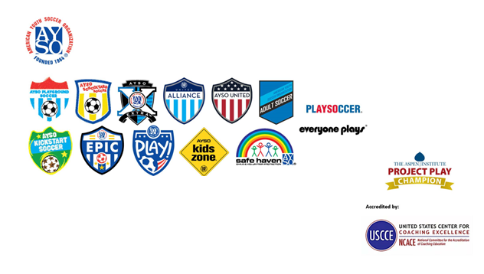
Copyright © 2025 by the American Youth Soccer Organization
All rights reserved. No part of this publication may be reproduced, distributed or transmitted in any form or by any means, including photocopying, recording, or other electronic or mechanical methods, without the prior written permission of the publisher, except in the case of brief quotations embodied in critical reviews and certain other noncommercial uses permitted by copyright law. For permission requests, write to the publisher, addressed “Attention: Risk Manager,” at the address below.

AYSO Office
19700 S. Vermont Ave., Suite 103
Torrance, CA 90502
(800) 872-2976 | 424-221-7900
www.ayso.org
Content

1. AYSO Standard Regional Policies and Protocols 1:1
Article One: Introduction and Purpose 1:1
Article Two: Mission 1:2
Article Three: Corporate Governance 1:2
Article Four: Duties and Responsibilities of the Region 1:2
Article Five: Membership in the Region 1:4
Article Six: Management of the Region 1:4
A. Regional Commissioner and Regional Board Member Composition 1:4
B. Duties and Responsibilities of Mandatory Regional Board Positions 1:5
C. Meetings 1:7
D. Voting and Veto Powers 1:7
E. Regional Commissioner Initial Appointment/Reappointment/Replacement 1:7
F. Regional Board Member Selection and Appointment 1:8
G. Voluntary Service and Conflict of Interest 1:8
Article Seven: Program Vision and Administration 1:9
A. Representative Visionary Requirements 1:9
B. Operational Expectations 1:9
C. Best Practices and “How-Tos” 1:10
Article Eight: Financial Banking and Related Matters 1:10
Article Nine: Dispute Resolution and Due Process 1:11
Article Ten: Regional Amendments to Standard Regional Policies and Protocols 1:12
A. Adoption of AYSO Standard Regional Policies & Protocols 1:12
B. Amendment to the AYSO Standard Regional Policies & Procedures 1:12
C. Publication of P&Ps and Addendums 1:13
AYSO Standard Regional Policies & Protocols - Attachments 1:13
A. SR P&Ps Addendum Form 1:13
B. Additional Region Policies and Guidelines 1:15

AYSO Standard Regional Policies and Protocols

Article One: Introduction and Purpose
Welcome to the heart of the American Youth Soccer Organization – its Region.
The AYSO Region is where “the beautiful game of soccer” meets the children of our cities, townships and counties and in the process educates and develops our Nation’s young people through AYSO’s six philosophies of Everyone Plays®, Balanced Teams, Open Registration, Positive Coaching, Good Sportsmanship and Player Development. (See AYSO National Bylaws, Section 1.01 and Article Two of these Standard Regional Policies and Protocols.)
These Standard Regional Policies & Protocols (P&Ps) have been established as a Governing Document by the National Board of Directors (NBOD) pursuant to the authority granted in Article One, Section 1.03(a)(6) and (11) of the AYSO National Bylaws and in support of AYSO's other Governing Documents (Articles of Incorporation, National Bylaws, National Policy Statements and National Rules & Regulations). They are designed to inform the Regional Leadership (Regional Commissioner and Regional Board Members) about how an AYSO Region must be administered, and to assure a successful and rewarding experience by our AYSO volunteers, players and families.
Pursuant to Bylaw 1.04(l) and NPS 6.1, the Region has the responsibility to operate in accordance with these P&Ps unless the Region has obtained permission from the NBOD or its delegate to vary from these requirements, through the addendum process set forth in Article Ten of these P&Ps. Any such variation must also comply with any Rules & Regulations appropriately adopted by the Region's Area Director and/or Section Director, pursuant to Bylaw 8.03. To the extent that there may be any contradiction or conflict between these P&Ps, including any approved Addendum thereto and other AYSO Governing Documents, the other AYSO Governing Documents will prevail.
While these P&Ps are intended to advise AYSO's local leaders about what is required to operate a Region, suggested "Best Practices" about how to operate a successful Region can be found within the AYSO Reference Book Chapter 8.
Finally, know that you are not alone; Your NBOD, Section and Area Directors and the AYSO Office Staff stand ready to support you and all who you serve. So, if you have questions, just ask!

Article Two: Mission
The AYSO Mission is to develop and deliver quality youth soccer programs which promote a fun, family environment based on the AYSO philosophies:
Everyone Plays® - Our goal is for kids to play soccer⎯so we mandate that every player on every team must play at least half of every game.
Balanced Teams - Each year we form new teams as evenly balanced as possible⎯because it is fair and more fun when teams of equal ability play.
Open Registration - Our program is open to all children who want to register and play soccer. Interest and enthusiasm are the only criteria for playing.
Positive Coaching - Encouragement of player effort provides for greater enjoyment by the players and ultimately leads to better-skilled and better-motivated players.
Good Sportsmanship - We strive to create a safe, fair, fun and positive environment based on mutual respect, rather than a win-at-all-costs attitude, and our program is designed to instill good sportsmanship in every facet of AYSO.
Player Development - We believe that all players should be able to develop their soccer skills and knowledge to the best of their abilities, both individually and as members of a team, in order to maximize their enjoyment of the game.
(See Bylaw 1.01 and Reference Book, Chapter 6, AYSO Fundamentals.)

Article Three: Corporate Governance
AYSO is a single California corporation. Each Region is a part of that corporate entity and, as such, the assets and liabilities of the Region belong to the Corporation. Similarly, it is possible for the conduct of a Regional Board Member to impose legal obligations upon AYSO. Consequently, all material contracts in excess of one year duration, including proposed leases of fields or property must be reviewed and approved by the NBOD or its delegate and prior to their execution.
Since we are one corporation, no AYSO volunteer may file a lawsuit in the name of AYSO without the prior written approval of the AYSO Office and any claim/lawsuit against an AYSO Region or Executive or Participating Member must be immediately reported to the AYSO Office. Finally, AYSO takes great pride in its brand identity and in the trademarks, logos and other items of Intellectual Property it has developed over the years. (See NPS 1.1 for the requirements and proper use of trade name, trademark and logos.)
(See Bylaws 1.03, 1.04(p), and 9.02; NPS 1.1, 1.3, 3.5, 3.6, 3.11, 4.5, 5.3; and the Reference Book, Chapter 8.)

Article Four: Duties and Responsibilities of the Region
The obligations required of every AYSO Region are set out in AYSO’s Governing Documents. The most significant of those are:
- To operate and offer quality youth soccer programs, which promote a safe, fair, fun and positive environment that complies in spirit and letter with the Bylaws, NPS, R&Rs, and Philosophies of the Organization. (See Reference Book, Chapter 7, AYSO Fundamentals.)
- To elect or appoint, at a minimum, a Regional Commissioner, Treasurer, and a third board member to assist with Regional operations. At the discretion of the Region, when volunteers are available, elect or appoint a Coach Administrator, Referee Administrator, Safety Director, Child & Volunteer Protection Advocate (CVPA) and Registrar. (At least one board member must be trained, designated as, and responsible for the CVPA position; the responsibilities of the remaining unfilled positions should be assumed by the three required members). (See Bylaw 1.04 (n), Article Six, Paragraphs E and F.)
- To register all players, coaches, referees, administrators and other volunteers prior to the commencement of the season and, as applicable, throughout the season, in accordance with the registration procedures of the Organization.
Please note that the failure of a Region to properly register a player or volunteer on a timely basis presents significant risk management and insurance issues that could result in severe sanctions, including but not limited to, revocation of the Region’s charter, removal of the RC, and/or holding the Region responsible for payments under the Soccer Accident Insurance program.
(See Bylaws 1.04(c) and 1.04(t) and NPS 3.7 for a discussion of the registration and application requirements and procedures for the registration of volunteers and players.)
- To comply with the Volunteer Protection Act of 1997 by ensuring that all volunteers: are trained and certified; are given a position description, preferably in writing; and know and perform their duties consistent with AYSO’s Governing Documents. (See NPS, Article Nine9, Safe Haven, for a discussion of the Federal Volunteer Protection Act of 1997 and the requirements for a volunteer to obtain the legal protections it affords, and Chapter 15, for a listing of approved AYSO Position Descriptions.)
- To assign players and coaches to assure proper balance of teams within each age division within the Region or within a reasonable geographical part thereof; (See Bylaw 1.04(d).)
- To ensure the financial integrity of the Organization by complying with the obligations established by Bylaw 1.04(l) and (m), including, but not limited to, the timely payment of all National Player Registration Fees in accordance with the registration requirements and procedures of the Organization. (See Article Eight, Financial Banking and Related Matters, of these P&Ps, AYSO’s Financial Policy, Reference Book, Chapter 6);
- To comply with the Soccer Accident Insurance (SAI) plan and to submit insurance claims according to current procedures; (See Bylaw 1.04(o) and www.AYSO.org, Volunteers/Insurance.)
- To educate and inform its members that AYSO, its employees and volunteers, is a mandated reporter and asks that any adult who knows or suspects child abuse or neglect, file a good faith report. (See NPS Article Nine, Reference Book, Chapter 9, Safe Haven). Please contact Risk Management, at the AYSO Office with any questions).
- To contact the AYSO Office if it believes that events in their community, even those not related to AYSO or youth sports, may create heightened sensitivity with respect to AYSO, its programs or its reputation; and
- To comply with the requirements set out with NPS 2.5 and all directions provided by the AYSO Office whenever a Region is considering paying for services to be rendered. (See Paying for Services on the AYSO website at www.ayso.org and also Article Six, Paragraph G of these P&Ps.)
(See Bylaw 1.04.)

Article Five: Membership in the Region
- There are three categories of members in AYSO: Executive Members, Participating Members and Honorary Members:
- EXECUTIVE MEMBERS: Every RC of a Chartered Region is an Executive Member. While RCs of Pilot Regions generally have most of the rights and responsibilities of their peers in Chartered Regions, they are not Executive Members and, therefore, do not have the right to vote, including at the National Annual General Meeting or in connection with the nomination of an Area Director. (See Bylaws 1.05, 1.06, and 7.02.)
- PARTICIPATING MEMBERS: All properly registered and accepted players and volunteers (except for RCs) within the Region are Participating Members.
- HONORARY MEMBERS: An Honorary Member is someone who has rendered outstanding or extraordinary service to the Organization, as recognized by the NBOD.
(See Bylaws 3.03, 3.04 and 3.02, respectively and AYSO Hall Of Fame Nominations on the AYSO website, www.AYSO.org, for nominating procedures for National recognition and for establishing local "halls of fame".)
- The names, addresses and telephone numbers of all members of the Region, as well as the information contained in any Executive Member directory or any AYSO database are private and confidential. Such information and mailing lists or access to any AYSO database may not be disclosed or distributed to anyone, including any vendor or sponsor, without the prior written approval of the National Executive Director. (See NPS 1.2.)

Article Six: Management of the Region
The management of an AYSO Region requires conduct consistent with AYSO’s Governing Documents and discretionary decisions that a Region believes are necessary to operate a successful AYSO program in that Region’s unique environment. In AYSO’s Governing Documents, words such as “required”, “shall” and “shall not” describe mandatory acts. Words such as “may”, “could”, and “might” refer to decisions or acts considered to be discretionary. (For a discussion of recommended/discretionary “Best Practices” in the management of a Region, please see the Reference Book, Chapter 8.)
The following is a list of some of the more significant Regional Board management obligations.

Regional Commissioner and Regional Board Member Composition
- Upon creation of the Region by the NBOD, the RC shall appoint the initial Regional Board to serve until the first scheduled Regional Board meeting, at which time nominations for board positions will take place, subject to appointment by the RC.
- The Regional Board shall, at a minimum, consist of the RC, the Regional Treasurer, and a third Board Member, one of whom will serve as the designated, trained and certified Child and Volunteer Protection Advocate. When volunteers become available, appoint a Regional Risk Manager/Safety Director, Regional Coach Administrator, Regional Referee Administrator, Regional Registrar and Regional Child and Volunteer Protection Advocate, all of whom are voting members. With the approval of the Regional Board, a person may serve in more than one position with the exception of the RC who cannot also serve as Regional Treasurer. In any case, where a Regional Board Member serves in more than one voting position, there is only one vote per person, not one vote per position. (See Bylaw 1.04 (n).)
- The RC, in consultation with the Regional Board, may create such other voting or non-voting Board Members or other staff positions, as deemed desirable. Unless specifically noted to be a non-voting Board Member, as required pursuant to the Addendum procedures set out within Article Ten of these P&Ps, all Regional Board Members will be deemed to be voting Board Members. The duties and responsibilities of these other positions shall be approved by the RC.
- All members of the Regional Board understand that they owe a duty of loyalty to AYSO and by accepting appointment to the Regional Board agree to be bound by AYSO's Governing Documents.
- All voting Regional Board Members must have reached the age of majority (adults), as defined by the State in which they reside, whereas youth volunteers may serve as non-voting Regional Board Members. (See NPS 2.15.)
- Regional Board Members serve a one year term, or until the next annual meeting of the Regional Board.
- Any Regional Board Member, other than the RC, may be suspended, limited in activities or removed, in accordance with the Dispute Resolution procedures approved by the NBOD. (See Article Nine of these P&Ps, Dispute Resolution and Due Process for non-executive members.)

Duties and Responsibilities of Mandatory Regional Board Positions
A brief overview of the duties and responsibilities of the seven mandatory Regional Board positions follows:

Regional Commissioner (“RC”)
- The RC, with the support and assistance of the Regional Board, shall have the responsibility and authority to conduct the day-to-day business affairs of the Region; guide the development of its future; and assure its compliance with AYSO’s Governing Documents. (See Bylaw 7.03.)
- The RC’s initial term of service shall be as appointed by the NBOD and the RC may serve multiple terms so long as they are nominated by the Regional Board and approved by the Area Director and/or Section Director and appointed by the NBOD. It is the responsibility of the RC to ensure that their term of appointment does not expire. If the term does expire, all system/data access rights previously granted to the RC will be revoked and the RC will no longer have the rights and privileges of an Executive Member including, but not limited to, the right to vote at an NAGM or in connection with the nomination of an Area Director. These limitations will remain in place until such time as the RC’s application for reappointment, if any, is approved by the NBOD. (See Bylaw 7.05 and NPS 4.6; see also Policy for Access Rights.
- The RC, in concert with the Regional Treasurer, shall insure that all fees collected, and monies disbursed, are done so in a fiscally responsible manner as described in Bylaw 1.04(m). (See Reference Book, Chapter 15, RC Job Description.)
- The RC, or delegated Member of the Regional Board, shall preside at all Regional Board meetings. (See Reference Book, Chapter 15, RC Job Description)
- The RC shall maintain close liaison with the Area and Section Directors. (See Bylaw 7.03.)
- The RC shall act in all ways to avoid even the appearance of a conflict of interest. (See NPS, Article Five “Standards of Conduct and Conflict of Interest”.)
- The RC may be suspended by the Area Director or the Section Director and suspended or removed by the NBOD in accordance with the Bylaws. (See Bylaw 7.03.)

Regional Treasurer
The AYSO volunteer position of Regional Treasurer shall have custody of all funds and securities, evidence of indebtedness and other valuable documents, and shall deposit funds and securities in the name and to the credit of the Region in a bank or depository. The Treasurer shall comply with AYSO’s Governing Documents, including but not be limited to the following obligations: the preparation and maintenance of the Region’s financial statements and their dissemination to the Region’s participants and the AYSO Office, the timely payment of all National Player Registration Fees, the full participation of the Region in the National Accounting Program, including Accounting Systems of record, the AYSO Policy on the Reimbursement of Expenses Incurred by the Region’s Members, proper bank account maintenance and AYSO’s Player Refund Policy. (See Bylaws 1.04(l) and (m); NPS 3.1, 3.2, 3.9 and 3.10; and the AYSO Financial Policy, Reference Book, Chapter 6).

Regional Risk Manager/Safety Director
The AYSO volunteer position of Regional Risk Manager/Safety Director shall be responsible for the overall aspects of the Region's safety plan including the safe condition of the Region's equipment, goals and fields and for ensuring that the Region's players, volunteers and parents are aware of AYSO's Soccer Accident Insurance (SAI), and AYSO's Incident Report Procedures. This position, together with the RC, is also responsible for implementing and monitoring AYSO's Severe Weather and Concussion Awareness Policies. (See Bylaws 1.04(e), (f), and (o), as well as NPS 2.10, 2.13, and 2.14.)

Regional Coach Administrator (“RCA”)
The AYSO volunteer position of RCA is responsible for implementing, monitoring and maintaining the AYSO National Coaching Program at all age levels within the Region, including program delivery, volunteer training and certification (AYSO’s Safe Haven, U.S. SafeSport and state required health and safety trainings), as well as staff development, communication and coordination. (See Bylaw 1.04(q) and the Reference Book Chapter 7, AYSO Fundamentals (Programs), and Chapters 9, 10, National Coaching Program.)

Regional Referee Administrator (“RRA”)
The AYSO volunteer position of RRA is responsible for implementing, monitoring and maintaining the AYSO National Referee Program at all age levels within the Region, including the program delivery, volunteer training and certification (including AYSO’s Safe Haven, U.S. SafeSport and state required health and safety trainings)), as well as staff development, communication and coordination. (See Bylaw 1.04(q) and the Reference Book Chapter 7, AYSO Fundamentals (Programs), and Chapter 11, National Referee Program.)

Regional Registrar
The AYSO volunteer position of Regional Registrar is responsible for the planning and implementation of the annual registration of all players. The Regional Registrar shall comply with AYSO’s Governing Documents, including but not limited to: the registration of all players prior to the commencement of the season and, as applicable, throughout the season, in accordance with the registration and application requirements and procedures of the Organization. (See Bylaw 1.04(c).)

Regional Child & Volunteer Protection Advocate (“CVPA”)
The AYSO volunteer position of Regional CVPA is responsible for overseeing the Safe Haven Program within the Region. This includes working with the RC, RCA and RRA to ensure Safe Haven training and certification of all coaches, referees and other volunteers in the Region. The CVPA is also responsible for the screening and registration of all regional volunteers prior to the commencement of the season and, as applicable throughout the season, in accordance with the registration and application requirements and procedures of the Organization. Finally, the CVPA, together with the RC, is also responsible for the implementation and monitoring of AYSO's Code of Conduct Policy against Harassment, Abuse, or Violence. (See Bylaw 1.04(c), NPS 2.12, 3.7, and Article Nine, together with Reference Book, Chapter 9, and AYSO Safe Haven.)

Meetings
As established within Bylaw 1.04(k), and consistent with the principles of established corporate governance, every Region shall hold an annual and thereafter periodic meetings of the Regional Board, conducting these meetings in an open and transparent fashion, excepting for any necessary executive sessions, and maintaining minutes thereof, which minutes are to be reasonably made available to the Regional Board, the Region's Participating Members, and the AYSO Office.
For a listing of recommended “Best Practices” in the administration of the Region’s Board meetings, the limitations of when executive sessions are permissible, the requirements of a quorum and the general responsibilities of Regional Board Members, see the Reference Book, Chapter 8.

Voting and Veto Powers
Unless otherwise specifically provided by these P&Ps, decisions of the Regional Board must be made by a majority decision of the voting Regional Board Members deciding on any such matter; provided, however, that the RC may veto any such decision if (a) the effect of such decision would be to violate any of AYSO’s Governing Documents or applicable law or (b) in the RC’s discretion, as guided by fiduciary obligations, would not be in the best interests of the Region or the Organization.

Regional Commissioner Initial Appointment/Reappointment/Replacement
  - When a new Pilot Region is formed, the NBOD appoints the initial RC based upon information provided by the applicable Area and Section Directors and the AYSO Office. (See Bylaw 1.05.)
  - Once the Initial RC is appointed, a Regional nominating committee shall be established by (i) the RC, in consultation with the Regional Board, at least three months, and preferably six months, before the expiration of the RC’s term or the end of an RC’s term due to planned resignation, or (ii) the Regional Board, whenever there is a vacancy in the RC position due to the RC’s death, unexpected resignation or removal.
    - The nominating committee will be comprised of a reasonable number of both Regional Board Members and Regional Participating Members who are not players or Members of the Regional Board.
    - The nominating committee shall submit its list of one or more names of individuals who they have determined to be qualified as candidates for the position of RC to the Regional Board. The voting members of the Regional Board shall, by a majority vote, nominate an RC and forward such nomination to the Area and Section Director, whose territory includes the Region. If both the Area Director and Section Director approve of the nomination of the person as Regional Commissioner, then the nomination will be forwarded to the National Board of Directors for election. (See Bylaw 7.03)
    - In the absence of a nomination by the Regional Board, it is the responsibility and authority of the Region’s Area Director to work with the Region to ensure that an RC is nominated.
    - The NBOD has full discretion whether or not to appoint a nominee or to appoint a nominee for a term of three years or for a shorter period as it deems appropriate, after taking into account any input provided by the Area Director and/or Section Director.
    - In the event of a vacancy in the position of RC, the Region’s Area Director or other NBOD designee will step in and become the acting RC and work with the Regional Board to continue the operations of the Region until such time as a nominee for RC has been appointed by the NBOD. If there is no appointed RC, then the Region will not be represented at any vote for an Area Director or have a vote at an NAGM. (See Executive Member Selection Protocol under Best Practices in the Reference Book.)

Regional Board Member Selection and Appointment
- At least one month prior to the annual meeting of the Region, or from time to time as may be needed, the RC shall appoint a nominating committee of not less than three individuals, consisting of Regional Board Members, one of whom shall serve as the Chair of the committee, and a reasonable number of Participating Members, who are not Members of the Regional Board.
- The nominating committee shall publicize to the Participating Members of the Region the Regional Board positions to be voted upon, recruit candidates and accept the names of interested candidates for consideration.
- Regional Board Members need not be parents of players in the Region.
- At the annual meeting or from time to time as may be needed, the nominating committee shall present to the outgoing Regional Board a list of qualified candidates. By majority vote of the outgoing Regional Board Members present and voting, the final list of recommended nominees shall be presented to the RC for approval and appointment.
- The RC may choose not to appoint a nominee to a Regional Board position, even though recommended, if the RC deems there is sufficient reason not to make the appointment. In such case, the RC shall ask the nominating committee to recommend additional candidates for approval and appointment. This inclusive and democratic process should be followed any time there are Regional Board positions to be filled, with the only exception being the appointment of the inaugural Regional Board.
- An emergency or unplanned vacancy on the Regional Board before the expiration of the term, except that of RC, may be filled by a replacement candidate nominated by a majority vote of the voting Regional Board Members and approved and appointed by the RC. The person filling such vacancy shall serve until the next annual meeting.

Voluntary Service and Conflict of Interest
- No Regional Board Member shall receive monetary or other compensation for their services to the Region related to their volunteer position. Nothing in this paragraph prohibits any Regional Board or staff member, or Regional participant, from being reimbursed for appropriate out-of-pocket expenses incurred on behalf of the Region and in accordance with the expense reimbursement procedures set forth within Reference Book, Chapter 6, AYSO’s Financial Policy, Chapter 8, Regional Operations, Financial Matters and NPS 3.1.
- Consistent with NPS 5, no Regional Board Member may use their position to benefit themselves directly or indirectly in any way, such as a supplier of equipment, materials or services to the Region except as permitted by NPS 2.5 and Article Four, Paragraph J of these P&Ps (Paying Volunteers) and the procedures established within NPS 5.3 (Conflict of Interest Policy).
- The Region may not reduce or eliminate a player fee based upon volunteer work done by a participant’s parents or guardians. Should a Region decide to incur the cost of the volunteer membership fee for its participating volunteers, an exception shall be made to allow a reduction of a player fee associated with the volunteer for an amount not exceeding the cost of the volunteer membership program. This rule does not impact the Region’s ability to set early registration discounts available to all participants, to create volunteer recognition programs, to provide scholarship programs and provide other programs available in the Region’s program. No fee distinction shall be made based upon parental or player participation in Regional fundraising activities.
- The Region may not condition the registration of a player based upon any requirement of volunteer participation by a parent or guardian.
(See NPS 5.)

Article Seven: Program Vision and Administration

Representative Visionary Requirements
The AYSO Mission of "Developing and delivering quality youth soccer programs which promote a fun, family environment" is best accomplished by assuring quality educational programs, implementing well-structured administrative systems, having an integral volunteer network focusing on AYSO's development; and guaranteeing a strong financial position. The following is a partial listing of acts necessary to best achieve these goals:
- Regions must implement the Safe Haven, Coaching, Referee, and Management Programs, with a focus on providing volunteer training opportunities throughout the year. (See Bylaws 1.04(h) and (q).)
- Regions must, at a minimum, implement AYSO’s Standard Primary Program on an annual basis and, to the best of their ability, participate year-round in the other various National Programs available and indicate which programs are available within their Policies and Protocols which may include but not limited to: EPIC, EXTRA™, Kids Zone™, a (U5), U-16/U-19, Soccerfest, Tournaments, and NAASA - AYSO Adult, together with attending leadership events such as RC Training, Nationally-supported Section events (Section Conferences/Meetings, AYSO EXPOS, etc.) and the National Annual General Meeting (NAGM). (See Bylaw 1.04(q) and (s).)
- Player and volunteer recruitment, development and retention must be a focus of the Region. (See Bylaw 1.04(h) and (r).)
- To assure that the Region enjoys a vibrant future, the RC and Regional Board are expected to develop reasonable fundraising and sponsorship opportunities. (See Bylaw 1.04(m).)
- The creation of both a short-term and long-range Strategic Plan for the future development of the Region is critically necessary and, once created, must be periodically reviewed and updated with the Area Director providing approval. (See Bylaw 1.04(r).)
(See Reference Book, Chapter 7, AYSO Fundamentals, Mission Statement Comments.)

Operational Expectations
A number of concrete steps is required to meet the previously stated visionary goals. The following is a partial list of many most often achieved by successful Regions:
- The Regional Board shall establish and communicate annually the registration fee for each player, as well as have a documented refund policy. (See Bylaw 3.06 and NPS 3.10.)
- Teams must be formed as established in Articles II and III of the R&Rs, assuring a proper balance of teams within each age division within the Region or within a reasonable part thereof. (See Bylaw 1.04(d).)
- The only team member(s) head coaches may specify to be on their team is their own child or children. Otherwise, there shall be no automatic retention of players on any specific team or with any specific coach from the previous season. (See R&Rs Article II, Paragraph G and Bylaw 1.04(d).
- Every player on every team must play at least one-half of every game; (See R&Rs Article I, Paragraph C.1.)
- Regions shall provide all necessary equipment (including goals, nets and corner flags) and, for all players, provide matching team uniforms, consisting of jerseys (with an approved AYSO Logo), shorts and socks. (See Bylaw 1.04(f) and R&Rs, Article VI, Paragraph A.) Any variances shall be outlined as an addendum to the Region’s Standard Policies and Protocols.
- The highest standards of conduct and good sportsmanship, consistent with the AYSO philosophies, must be maintained at all times by players, volunteers and spectators. (See NPS 2.12 (AYSO’s Code of Conduct Policy against Harassment, Abuse, or Violence).)
- Offensive, insulting or abusive language, the consumption of alcoholic beverages, smoking or simulating smoking, or the use of tobacco products, at Regional-sponsored events whenever children are present, is forbidden. (See, in part, R&Rs Article I, Paragraph E.1 (d) and (e).)

Best Practices and “How-Tos”
To assist the Region in meeting its responsibilities and in achieving the greatest successes possible, proven “Best Practices” and “How-Tos” can be found in the AYSO Reference Book, Chapter 8, the AYSO Wiki, and AYSO’s Online Training Library.

Article Eight: Financial Banking and Related Matters
Consistent with the obligations established within Bylaw 1.04(l) and (m), every AYSO RC and Regional Board Member agree as a condition of the assumption of their Regional Board membership to comply with and assure proper oversight of the following financial obligations:
- All Regions must comply with the National Accounting Program and must adhere to the financial policies and procedures described in AYSO’s Financial Policy, Reference Book, Chapter 6 and the Treasurer section of the AYSO Wiki, unless otherwise authorized by the AYSO Office.
- An annual budget must be adopted that provides the basis for setting player registration fees and made available to the participants of the Region and to the Area Director and/or the Section Director no later than June 1st, which is 30 days prior to the end of the Organization’s fiscal year; (See Reference Book, Chapter 8, the AYSO Wiki and AYSO’s Online Training Library.) Region reserves should be in the range of one year’s worth of operating expenses.
- Ensure the financial integrity of the Organization by complying with the obligations established by Bylaw 1.04(l) and (m), and AYSO’s Financial Policy, Reference Book, Chapter 6, including, the timely payment of all national player registration fees prior to the commencement of the season and, as applicable throughout the season, in accordance with the registration requirements and procedures of the Organization.
- Any suspected financial irregularity/fraud or misuse of funds must be immediately reported to the Area Director, Section Director, and Finance Department of the AYSO Office.
- Regional financial records must be maintained for seven (7) years.
- The AYSO Office will provide authorized individuals an AYSO issued corporate credit card; The National Executive Director or AYSO Office Director of Finance and Accounting may approve credit cards to be issued in AYSO’s name to be used by Board members, staff members and executive members, consistent with the AYSO Financial Policy, Reference Book, Chapter 6. Authorized expenses shall be paid by AYSO’s approved credit card program or by check/electronic fund transfer from an approved AYSO operating account.
- All checking/savings accounts must have a minimum of three (3) signatories (the RC, Treasurer and Area Director, when reasonable), and any other Regional Board Member; and none can be related by marriage or blood.
- All checks must be signed by two (2) account signatories, one of whom should be the RC or Treasurer. At no time can a signatory sign for or authorize a check made payable to the signatory.
- Pre-signed checks and blank checks cannot be used.
- Only one (1) checking account and two (2) savings accounts/CDs are permitted, unless previously authorized for Tournaments and/or Cultural Events.
- All bank accounts must be in a federally insured banking institution (FDIC). Credit Unions are not approved banking institutions.
- Payments to independent contractors (vendors) must be reported to the AYSO Office for the potential issuance of 1099 forms.
- Fundraising in various states may trigger the obligation to pay sales or other various taxes. Whenever fundraising is considered, the AYSO Office must be contacted to determine if a tax applies.
- Tournaments must be self-sustaining as Regional funds cannot be used. Similarly, Regional funds cannot be used to subsidize traveling AYSO teams, but can be used to cover many Regional operating expenses for hosting Cultural Exchanges.
- Please consult the AYSO Wiki for “How-Tos” and “Best Practices” for the following: cash handling protocols, submission of monthly financial reports, coding of income and expenses, audits of Region finances, reconciliation of registered players to player registration fees received, refund policies, requirements of Auditors, volunteer reimbursement, attendance at Nationally-supported Section events and the NAGM, land ownership and leaseholds, AYSO Supply Center purchases and other similar subjects.
(See Bylaw 1.04(l) and (m), together with the AYSO’s Financial Policy, Reference Book, Chapter 6 and the Treasurer's Position Description contained in the Reference Book, Chapter 15.)

Article Nine: Dispute Resolution and Due Process
The successful resolution of disputes involving the day-to-day activities of AYSO volunteers is one of the most important goals in achieving a harmonious and healthy Region. As such, guiding principles such as "compromise," "suspension or removal as the last resort," the "recognition of valuable service" and "finding a fair and just resolution" are the cornerstones of AYSO's approach in dealing with such situations.
While the concepts of Dispute Resolution and Due Process apply to both Executive Members (RCs) and Participating Members, there are differences between the procedures and protocols. As a result, the following discussion only applies to the Region's Participating Members. (See Article five of the P&P's for the definitions of Executive and Participating Members.)
When a Participating Member's conduct, or that of a parent or guardian, even if not a Participating Member, has risen to the potential need of "limiting, suspending or removing/terminating" that person's participation in AYSO, the Region must follow the Due Process protocols adopted by the AYSO NBOD, as authorized within National Bylaw 3.07(d). While these procedures and protocols are set out in their entirety in the Reference Book, Chapter 8, Due Process, the following are several of the more significant provisions:

- When disciplinary action is found to be necessary, only the minimum action necessary should be taken. In that spirit, when possible, the Member should be allowed to resign, and disputes should not be publicized to respect their individual privacy.
- Regions must avoid punishing a player for the conduct of the parents, except when there is no other solution.
- There are required means by which Notice of the contemplated action must be given.
- The RC is ultimately responsible for determining which of several alternative Due Process procedures will be used.
- If the gravity of a person's conduct presents an imminent danger to any participant or to the program, the RC may immediately suspend the person(s) involved.
- The RC has the ultimate authority to remove a Participating Member, a parent or guardian, as well as those not entitled to Due Process, such as other family members and spectators, from further involvement in the program.
- A precise Due Process procedure has been established for holding a "Disciplinary Review Panel."
- A onetime Appeal Process has also been established to verify that the original determination was not arbitrary or capricious, that the original procedure was fair, and that the established procedures for Due Process were followed.
- Any abuse, assault and/or gross misconduct directed at any match official is subject to being disciplined in accordance with U.S. Soccer Policy 531-9 Misconduct Toward Game Officials in Amateur Matches, which policy is effective March, 2025.
If questions arise, please do not hesitate to contact your Area Director, your Section Director and the AYSO Office.

Article Ten: Regional Amendments to Standard Regional Policies and Protocols

Adoption of AYSO Standard Regional Policies & Protocols
These AYSO Standard Policies & Protocols (P&Ps) shall be deemed adopted by the Region, unless and until amended as set forth below. (See NPS, Article Six.)

Amendment to the AYSO Standard Regional Policies & Procedures
Should a Region desire to amend these P&Ps, it may only be accomplished with the following steps:
- A two-thirds (2/3) vote of the Regional Board Members.
- The recommendation of the RC.
- Copies of the signed Standard P&Ps Addendum Form, with the recommended change(s), sent by the RC to the Area Director, Section Director and the AYSO Office.
- Approval by the NBOD or its delegate.

Publication of P&Ps and Addendums
The Region must make these P&Ps, along with any Regional addendums, if they exist, available upon request to the members of the Region pursuant to Bylaws 1.04(i) and (l).

AYSO Standard Regional Policies & Protocols - Attachments

SR P&Ps Addendum Form
This form, the SR P&P Addendum Form, available on the AYSO website, www.AYSO.org and AYSO Wiki, is intended to capture all appropriate changes to the SR P&Ps that the Region determines is best for its members and community. This could include, for example, “having ¾ play before any player plays the full game”.

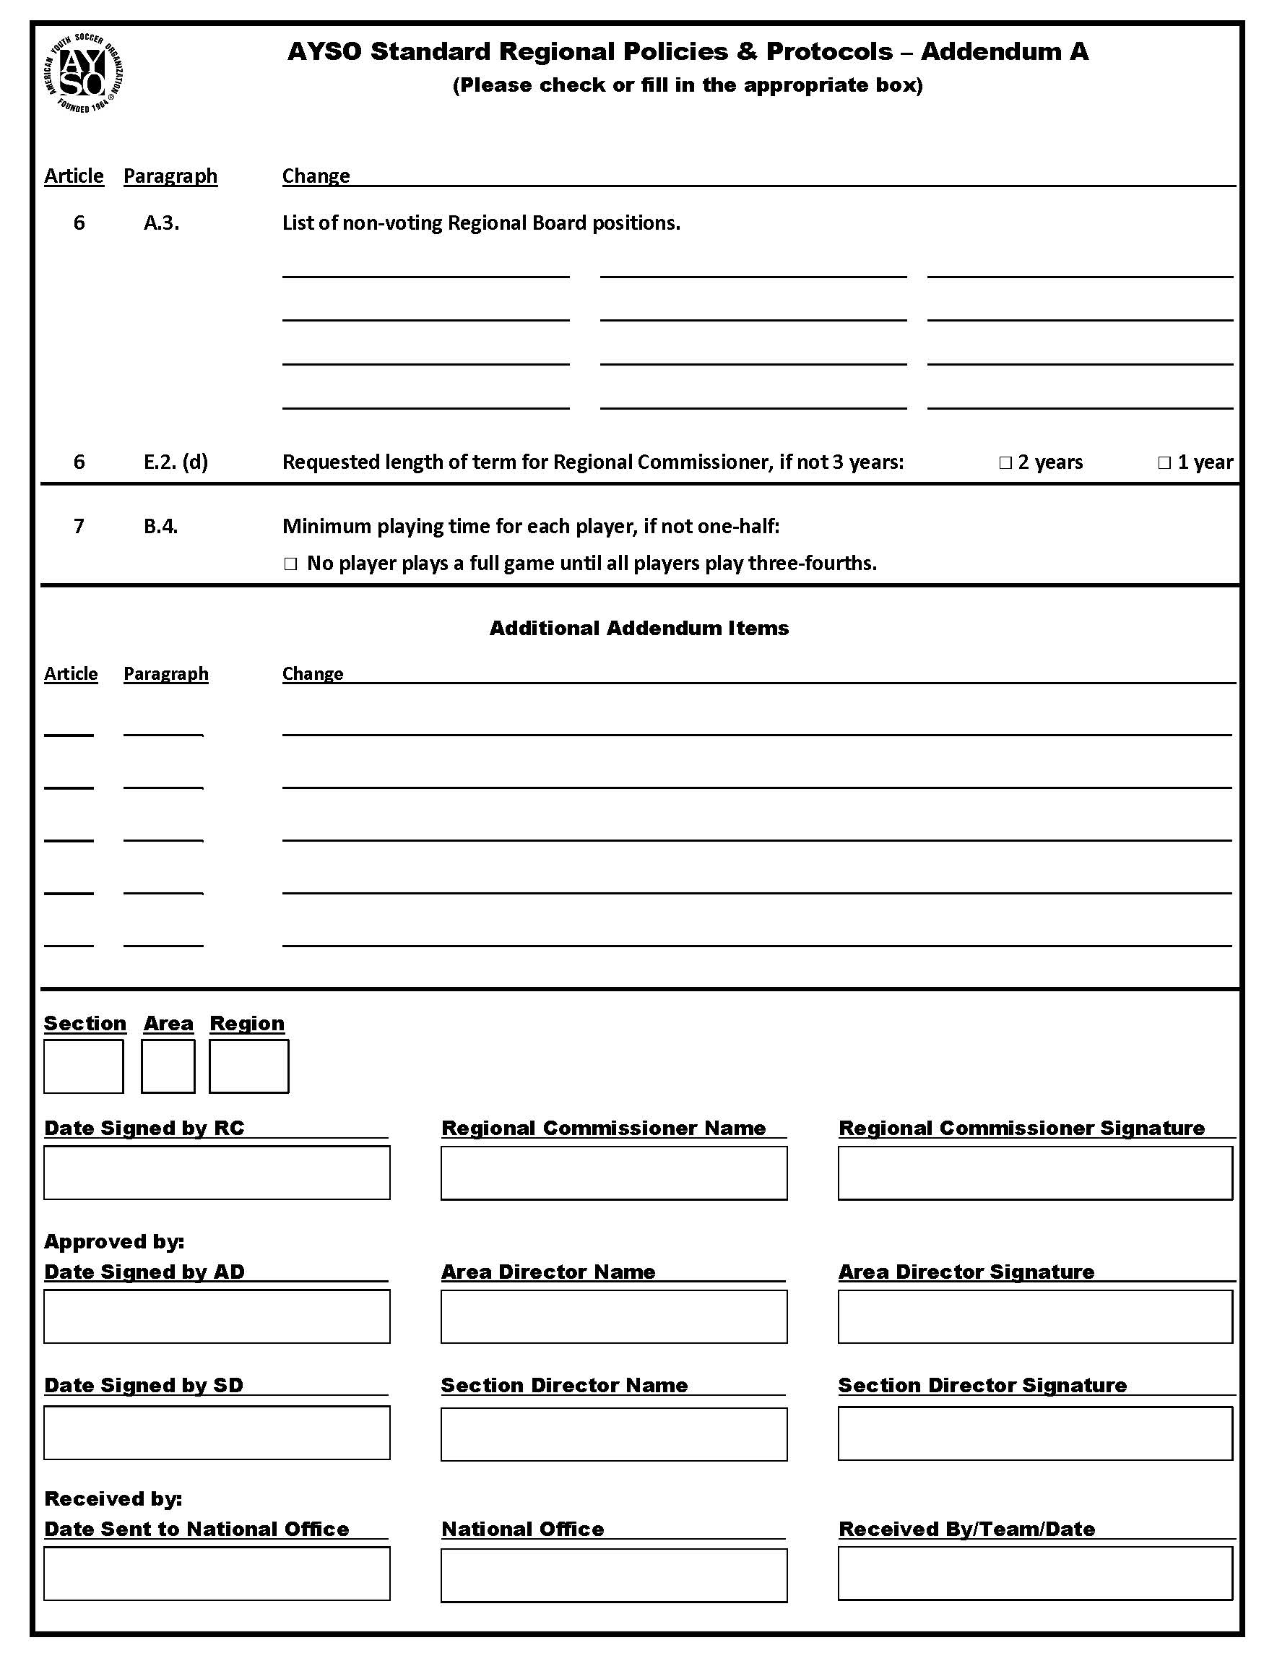

Additional Region Policies and Guidelines
Regions with additional Region-specific policies and guidelines, not covered in the AYSO Standard Policies and Protocols, are required to submit these policies and guidelines for review and approval by the Area Director, Section Director and NBOD or its delegate. The following Addendum B Cover Sheet must be used to itemize each local policy and guideline approved by a two-thirds vote of the Regional Board and be accompanied by a full copy of these Regional policies and guidelines. Examples of Region-specific policies and guidelines may include a Registration Fee Refund Policy, Player Sponsorship Guidelines, All-Star Team or Secondary Play Selection Criteria, etc.
The signed and approved SR Addendum and Addendum B, including a complete copy of any Regional policies and guidelines, must be forwarded to the AYSO Office upon approval.

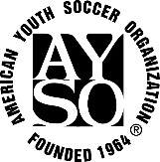 Addendum B – Additional Regional Policies and Guidelines

# | Policy or Guideline
1.0 | Player Registration – Registration Fee Refund Policy

These Standard Regional Policies & Protocols are abbreviated and referred to as the P&Ps.
References to some of AYSO's Governing Documents have been abbreviated for ease of use, as follows; AYSO National Bylaws = Bylaws; AYSO National Rules & Regulations = R&Rs; and AYSO National Policy Statements = NPS.
All of AYSO's Governing Documents, including these P&Ps, are available on-line at www.ayso.org.
Through the Addendum process described in Article 10, Regions will have the opportunity to select the so-called “three-quarter rule” for their Regions, whereby no player will play an entire game unless all other players on the team will play at least “three quarters” of the game. This option is frequently used in Regions throughout AYSO.

